SWL-180 High-Speed Horizontal Cartoning Machine
Fully Automatic Horizontal Cartoner for Blister Cards, Bottles, Tubes, Sachets and Medical/Food Packaging
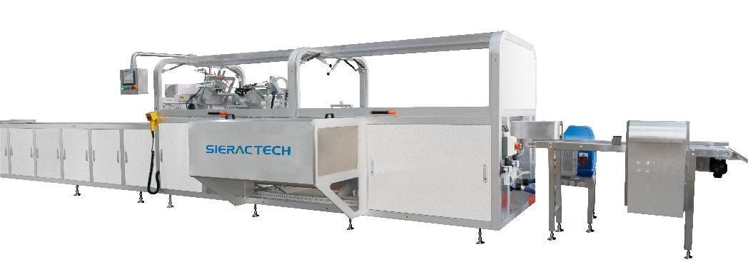

Website Product Page Fields
Field | Recommended English Content
H1 Title | SWL-180 High-Speed Horizontal Cartoning Machine
SEO Title | SWL-180 High-Speed Horizontal Cartoning Machine for Bottles, Tubes and Blister Cards
Meta Description | SWL-180 horizontal cartoning machine for bottles, tubes, blister cards and sachets, with PLC, servo control and GMP/CE design.

Product Description
The SWL-180 is a fully automatic high-speed horizontal cartoning machine developed for continuous carton forming, product loading and carton closing. It adopts rotary outward carton opening with a pre-forming mechanism to help the carton open completely before product insertion. The machine is designed with product and carton detection logic: no product, no carton feeding; product present but no carton, no pushing.
The control system integrates PLC control, HMI operation, servo control, electronic cam and variable-frequency speed regulation. Photoelectric sensors and encoders are used for material detection, carton detection, position feedback and interlocked machine actions. The equipment is suitable for packaging blister cards, bottles, tubes, sachets, soft double-aluminum packs and similar products in pharmaceutical, medical, food, daily chemical, lighting and confectionery applications.
Actual output and final configuration should be confirmed according to product characteristics, carton material, feeding method and project requirements.

6 Core Custom Attributes
Custom Attribute | Value
Product Type | Fully Automatic High-Speed Horizontal Cartoning Machine
Cartoning Format | Horizontal continuous cartoning; rotary carton opening with carton pre-forming
Output Capacity | Up to 100 cartons/min for the stated technical configuration
Carton Size Range | L100-260 mm x W25-260 mm x H25-65 mm
Applicable Products | Blister cards, bottles, tubes, sachets, soft double-aluminum packs and similar products
Control & Compliance | PLC + HMI + servo control + electronic cam; designed to meet GMP and CE requirements

Key Features
- Horizontal continuous cartoning structure using servo drive, mechanical cam and gear transmission, with modular design for operation and maintenance.
- PLC and HMI control with fault display, alarm information and finished product counting functions.
- Product-carton detection logic prevents carton feeding without product and prevents pushing when a carton is not detected.
- Optional automatic leaflet folding and insertion, coding, rejection and hot-melt glue sealing can be added according to project requirements.
- Suitable for daily chemical, pharmaceutical, medical, food, lighting and confectionery cartoning applications, and can be connected with upstream and downstream production lines.
- Designed with safety guarding, door interlock protection, missing-carton alarm and air pressure protection.

Technical Specifications
Item | Specification
Overall Dimensions | 9100 mm x 2200 mm x 1900 mm
Production Capacity | 100 cartons/min
Carton Range | Length 100-260 mm; Width 25-260 mm; Height 25-65 mm
Main Machine Power | 3 kW
Optional Hot-Melt Glue System Power | Approx. 6 kW
Air Consumption | 80 L/min
Air Pressure | 0.6 MPa
Machine Weight | Approx. 3 tons

Functional Module Description
Module | Description
Station Feeding System | Independent stainless-steel carrier station design with follow-up guide rail. The structure is convenient for changeover and maintenance and supports efficient connection with front-end feeding equipment.
Servo Carton Opening System | Multi-suction-head servo opening mechanism. During carton opening, the carton is pre-formed to support accurate carton shaping before product loading.
Detection Control System | Product photoelectric sensor detects material presence; carton opening sensor detects carton availability; carton magazine sensor alarms when cartons are insufficient.
Product Pushing and Cartoning System | Multi-pusher slow continuous feeding helps products enter the carton smoothly. Oil-nylon push heads are used to reduce direct product contact damage. A rotary pressing mechanism above the material plate supports controlled insertion.
Ear Closing System | Servo-controlled ear closing makes the closing speed and movement easier to adjust. Electronic cam and main shaft coupling help coordinate the closing action with the machine cycle.
Carton Sealing System | Optional glue sealing, tuck-in sealing or lock-bottom sealing mechanisms can be selected. Following-type sealing keeps the closing action synchronized with carton movement.
Safety Guarding | The machine includes automatic interlock protection, fault query, alarms, output counting, manual/automatic operation and protective covers. Door threshold alarm, missing-carton protection and air pressure alarm stop the machine when abnormal conditions occur.

Reference Module Images
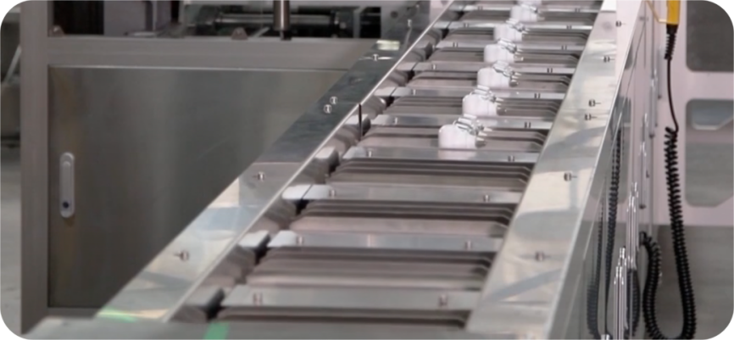  Station Feeding | 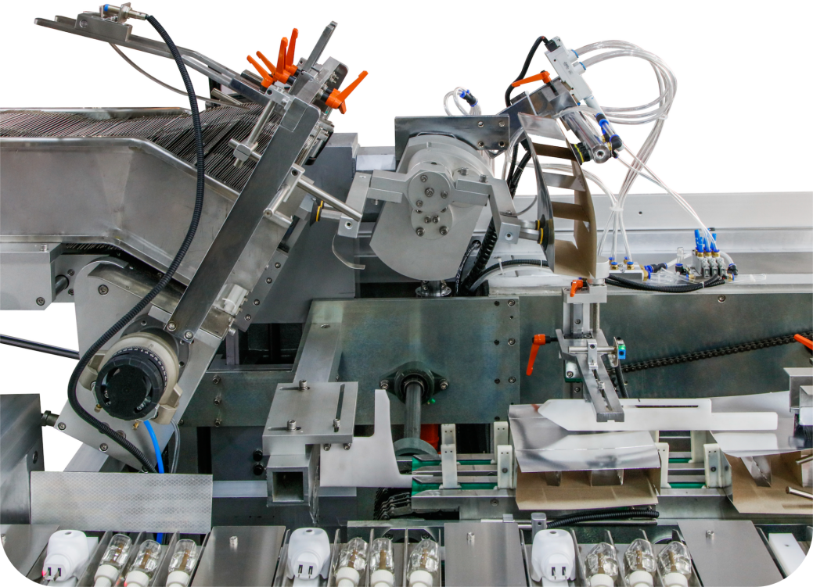  Servo Carton Opening
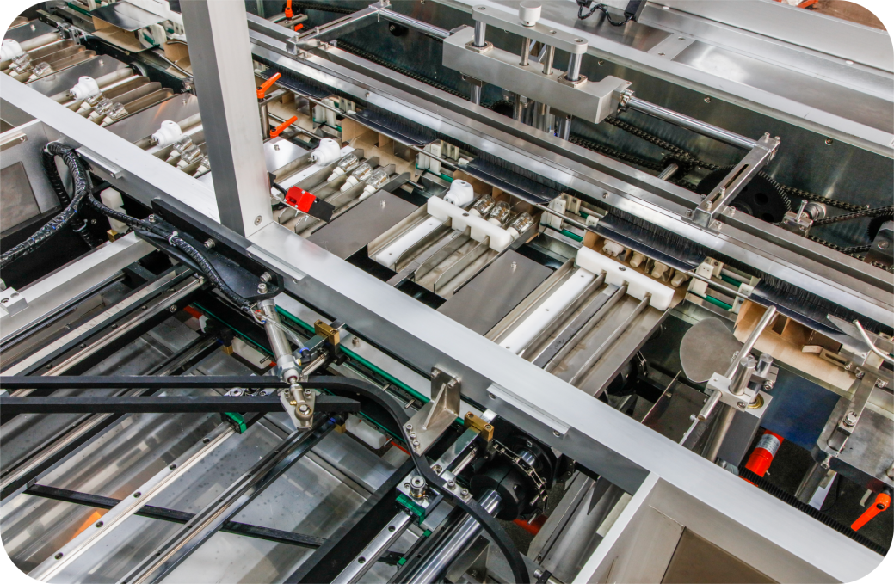  Product Pushing | 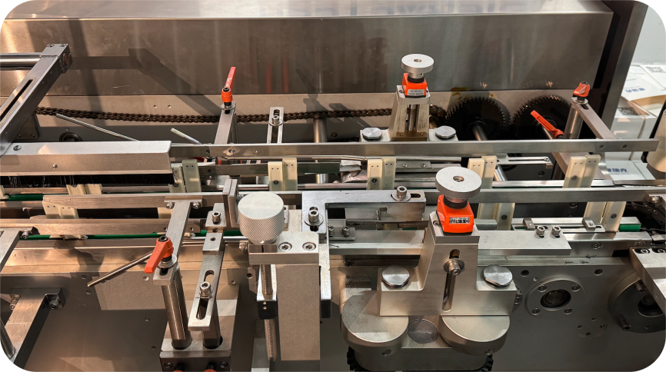  Carton Sealing Area

Application Range
The machine can be used for carton packaging in pharmaceutical, medical, food, daily chemical, lighting and confectionery production. Typical products include blister cards, bottles, soft tubes, sachets and soft double-aluminum packs. It can be integrated with upstream product feeding, leaflet handling, coding, rejection, checkweighing, case packing or downstream conveying systems according to the production line layout.

Electrical Configuration Reference
No. | Component | Brand / Reference
1 | Breaker | Schneider
2 | Button | Schneider
3 | AC Contactor | Schneider
4 | Power Supply | Schneider
5 | Control Relay | Schneider
6 | Multiple Relay | SIPAKE / IDEC
7 | Solid State Relay | SIPAKE / LI-DE
8 | PLC | Inovance
9 | HMI | Inovance
10 | Servo | Inovance
11 | Variable-frequency Drive | Schneider / Inovance
12 | Photoelectric Sensor | Pepperl+Fuchs / Sick
13 | Proximity Sensor | Autonics / Leuze
14 | Optical Fiber Amplifier | Omron / Panasonic / Leuze
15 | Solenoid Valve | Airtac
16 | Oil-Water Separator | Airtac
17 | Manual Slide Valve | Airtac
The final electrical configuration may be adjusted according to the actual project and procurement conditions, while maintaining an equivalent or higher configuration level.

Optional Functions and Line Integration
- Automatic leaflet folding and carton insertion.
- Date coding, batch coding, product inspection and rejection functions.
- Hot-melt glue sealing system, tuck-in sealing or lock-bottom sealing based on carton design.
- Connection with upstream product feeding systems and downstream conveying, checkweighing, case packing or palletizing equipment.

Summary
The SWL-180 horizontal cartoning machine provides an integrated solution for carton opening, product insertion, ear closing and carton sealing. With PLC/HMI control, servo-driven key movements, detection interlocks and configurable closing methods, it is suitable for automatic cartoning lines that require compact structure, clear operation logic and flexible integration with front-end and back-end packaging equipment.

